Code Division Multiple Access
System Analysis – Frequency Hopping

December 10, 2001

By: Firas Faham

Senior Engineer

Sensormatic Electronics

951 Yamato Road
Boca Raton, FL 33431

Frequency Hopping Spread Spectrum

Contents
Page

1. Abstract ------------------------------------------------------------------------ 2
2. Introduction -------------------------------------------------------------------- 2
3. The Wireless Link ------------------------------------------------------------- 3
4. Spread Spectrum ------------------------------------------------------------- 3
4.1. Frequency Hopping FHSS ----------------------------------------------- 5
4.2. Direct Sequence DSSS --------------------------------------------------- 8
5. Capacity Analysis ----------------------------------------------------------- 10
6. Performance Analysis ------------------------------------------------------ 16
7. Application Example ------------------------------------------------------- 22
8. Conclusion ------------------------------------------------------------------- 23

References Pages 24 and 25.

1. Abstract

In this paper, two CDMA Multiple Access techniques are presented. The Frequency Hopping Spread Spectrum FHSS and Direct Sequence Spread Spectrum DSSS are compared in term of interference, capacity, and data rate. The underlying idea is to implement a multiple access system capable of exchanging security data wirelessly while rejecting interference and multi path signals internal and external to the system. Orthogonal detection is presented and compared to bi orthogonal detection. Bi orthogonal coded detection provides a significant improvement over un coded detection. The paper also introduced the nature of Correlation between performance of the system in terms of Capacity and Outage and Bit Error Rate (BER), Signal to Noise Ratio (Eb/No), the size of systems symbol set, number of users M, systems dimension victor d, units separation factor, Processing Gain, and propagation characteristics.

2. Introduction

Our modern life necessitate a large, secure, reliable, and fast transfer of data and information over short and long ranges such as homes, offices, stores, and highways.

Wireless communication systems such as non-cellular, cellular, and PCS environment [WCPP] provide an increased convenience through simple yet sophisticated devices. Non cellular and non PCS or low tier cellular wireless systems take the advantage of communicating data and information over relatively short ranges and are characterized by a relatively lower power consumption, less complexity, and relatively higher user capacity per unit area. Unlike wired communication, wireless communication eliminate the need to run wires (cost, labor, and tangling), provides convenience and enhanced security and anti taping from wired services.

Wireless link eases connectivity, speeds up communication, and provides a considerable measure of security, and defeats possible interference and noises once designed properly. In an environment such homes, small offices, and department stores the 4 by 4 design considerations and challenges for enabling a necessary any-point to any-point communication link at any time are:

Minimizing:

Fading and interference from neighboring devices and adjacent channels.

External and internal noise disturbing information.

Cost and power consumption.
- Processing time.

Maximizing

Number of possible users per given area where needed.

Speed, reliability and throughput of information exchange.

Device mobility, flexibility, forward and backward compatibility, and ease of use.
- Information security, ease of system manageability, and device safety.
The advantages of the above mentioned 4 by 4 design considerations could be vast such as increased sales, better services, improved security, spread convenience, and so on…

3. The Wireless Link

Short range unlicensed micro radios (such as 200 meters) transceiver devices provide data link for use in control and security applications. The design of these devices became more of a system rather than merely a circuit. Other issues that also became an essential part of the micro radios wireless devices are regulatory issues [THB], choice of modulation schemes, type of transmission, type of antennas used, transmitter-receiver topology, frequency source topology, and synchronization methods [DACS].

4. Spread Spectrum

System that needs to be accessed by multi users in a noisy or static environment and with the possibility of cross-talk or interference may utilize different wireless topologies to accomplish this task. Spread Spectrum Multiple Access (SS MA) technology is among the most commonly used techniques to enable communication in a hostile environment [SSC1]. SS MA enables many users to share same frequency band (channel) and preserves the rest of the frequency spectrum. Among the other technologies used to enable this wireless link are Frequency Division Multiple Access (FDMA) and Time Division Multiple Access (TDMA.)

This is similar to the weekend party where pairs of people have similar language or interests. Only the two persons who speak the same language or share same interest can listen to each other and their conversation will not be affected by the other conversations. Language or interests resemble hopping codes in CDMA.
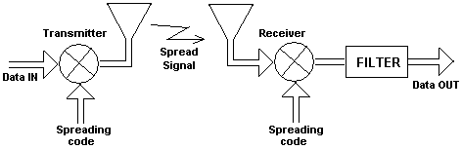

Figure 1. Simplified block diagram of the SS system.

The PN Spreading Code (language or interest) of the transmitter shown in Figure 1 above must be known to the receiver for the message to be detected or understood, and is independent of the intended message. The transmitter uses the PN Code to spread the message while the receiver uses the PN Code to de-spread the received signal. Efficiency of the system is determined by the maximum number of users that could use the system simultaneously, while keeping the number of dropped users to minimum. MA can be optimized for users per channel per bandwidth (or user per channel per mega hertz) or users per unit of geographical area. The former describes the number of users that can use the system over certain range of frequencies per a larger range of frequencies (frequency per frequency or channel per Mega hertz.) The later describes the number of users that can use the system over fixed range of frequencies per unit area.

The system performance (maximum number of simultaneous users, cost, and Quality of Service QoS) depends on the MA method used. Users per frequency per frequency can be visualized as 833 users each using a duplex channel pairs of 30 KHz with a total available spectral bandwidth of 70 MHz (or 1 user per 30 KHz per 70 MHz). The AMPS cellular system [WCPP] can support maximum of 833 users at a time. If more users attempt to access the system while 833 users are using the service the system will then block these new users. Frequency reuse, directional antennas sectoring, power control cell splitting, and Micro-cellular approach are among the methods used to increase system capacity over 833 users within a given geographical area.

On the other hand users per unit area topology uses a method called Code Division Multiple Access CDMA MA. Service area, modulation technology, Signal to Interference Ratio SIR, Signal to Noise Ratio SNR, Bit Error Rate BER, and will determine the maximum number of simultaneous users allowed by the system (systems user erlang) and the grade or quality of service.

Depending on the application, there are many different performance measurements (uses) for the SS MA communication system:

- Multiple random access capability with selective addressing capability
- Bandwidth efficiency
- Energy efficiency (SNR and BER)
- Interference rejection
- High resolution data transmission.
- Anti jam capability
- Covert operation or Low Probability of Intercept (LPI)

Spread spectrum is a CDMA technology [SSS] in which the radio transceiver prepares (processes) the information (analog or digital) signal for transmission over the air by spreading a signal's power over a wider band of frequencies, sacrificing bandwidth in order to gain improved signal-to-noise performance. The ratio of processed signal bandwidth over the un-processed signal bandwidth is referred to as processing gain GP. Wider spreading frequency bandwidth requires a relatively higher processing gain. The transmitted data signal becomes much less susceptible to noise and interference than that of conventional radio modulation techniques such as FDMA and TDMA. This type of frequency diversity allows further improvement for system capacity with multiple access. The reduction of noise and interference result in less error and higher measures of security when the receiver demodulates the signal.

Claude Shannon's [DCT] describes that in his famous equation:

C = W log2 (1+ S/N)
where C = Channel capacity in bits, W = Bandwidth in Hertz, S = Signal Power, and N = Noise Power. By increasing W in the equation, the S/N may be decreased without decreased BER performance. The process gain (GP) is what actually provides increased system performance without requiring a high S/N. This is described as:

GP = RFBW/INFOR
where RFBW is the RF Bandwidth in Hertz and INFOR is the Information rate in bits/second

FCC Part 15 of the radio spectrum regulation [CWCP] governs unlicensed devices transmitting under 1 watt of power in the Industrial, Scientific, and Medical (ISM) bands using spread spectrum modulation. The ISM frequencies are 902-928 MHz, 2.4-2.4835 GHz, and 5.725-5.850 GHz. FCC regulations also require manufacturers to use 75 or more frequencies per transmission channel with a maximum dwell time, the time spent at a particular frequency during any single hop, of 400 ms.

There are two frequently used SS MA methods: frequency hopping or direct sequence. The following sections will describe their basic operation:

4.1 Frequency Hopping FHSS

CDMA Multiple Access MA frequency hopping spread spectrum [MCSS] allows many users to access the system by using the same frequency band and without interfering with each others.

Transceiver pairs talk with each others by using a different Pseudo Random PN hopping pattern code, see Figure 2, that changes the carrier frequency (hops per bit), The hopping code is used to determine the transmission frequencies and to spread the original message and in which order. The receiver must be set to the same hopping code and must listen to the incoming signal at the right time (synchronized) and correct frequency in order to receive the intended signal.
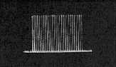

Figure 2. Frequency Spread in the FHSS.

Certain PN code frequency hopping software algorithms (some times hardware circuits are used) may deliver 7.2 x 10¹⁶ different hopping codes. This sequence repeats every 457 million years [www.qmac.com], ensuring a high level of security. These codes can be used in combat equipment and are easily changed on regular basis, such as once every month during peace time and once every week during combat. Another application area is international aid projects, mineral exploration, and search and rescue operations.

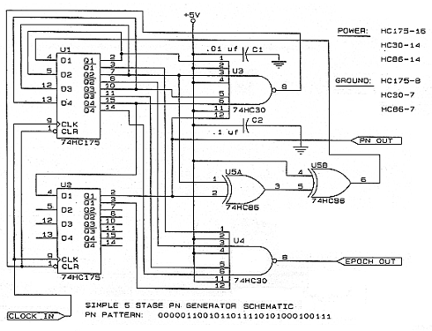

Figure 3. Example of PN Code Digital Electronic Circuit.

The transmitted signal level (power) is constant just before it leaves the antenna. The received FHSS signal will suffer multi-path fading in the airways as shown in Figure 4 and may vary its strength (power) as shown in the figure.
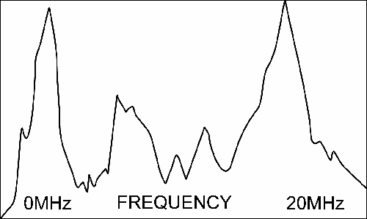

Figure 4. Wireless signals suffer from air ways. They are altered in magnitude and frequency (Doopler effect.)

For improved coherent detection, transceivers may employ Phase Shift Keying (PSK) or Frequency Shift Keying (FSK) transmissions [AECS].

While one radio is transmitting at one particular frequency, the other radio is using a different frequency. Sets of hopping codes that never use the same frequencies at the same time are considered orthogonal [DACS], however the hopping patterns are never truly orthogonal and interference occurs when two frequencies are used at the same time (hits.) The number of hits increases as the users number increase within the covered service area and bandwidth. The coding in SS MA give the advantage of power (bit energy) capture by the intended users while draining the power received by the un-intended users. Therefore, it is imperative to hide the code from un-intended users. Error detection and correction can be used to reduce the induced error caused by interference. FHSS technique, as shown in Figure 5, allows lower system cost, lower power consumption, high tolerance to interference, high system capacity, less susceptible to Far-Near field due to power control. The FCC's requirement for the number of different transmission frequencies allows frequency hopping radios to have many non-interfering channels.

Modulator
BPSK or FSK
m(t)

BPF
s(t)
Frequency Synthesizer
PN Code
Generator
BPSK or FSK Spread signal

Figure 5. Simplified block diagram of the FHSS system.

The frequency hopping technique reduces interference because an interfering signal from a narrow band system will only affect the spread spectrum signal if both are transmitting at the same frequency at the same time. Thus, the aggregate interference will be very low, resulting in little or no bit errors. A frequency hopping radio, for example, will hop the carrier frequency over the 2.4 GHz frequency band between 2.4 GHz and 2.483 GHz.

If the radio encounters interference on one frequency, then the radio will retransmit the signal on a subsequent hop on another frequency, depending on the hopping PN code pattern. Because of the nature of its modulation technique, frequency hopping can achieve up to 2 Mbps data rates.

At times, hopping channels are either being constantly used by adjacent transmitters, jammed, or blocked or are being severely affected by fading and multi-path. This hostile environment imposes an obstacle in providing a high quality reception. Smart Hopping enables avoidance of blocked channels by constantly monitoring the affected frequency spectrum of each channel within the hop set. All network members continuously receive this data. Affected channels are then automatically avoided.

4.2 Direct Sequence DSSS

CDMA Multiple Access MA Direct Sequence spread spectrum DSSS [DACS] is similar to FHSS except that it multiplies the digital data signal m(t) by a Pseudo Random Noise, noise like, Code PN-code. A PN-code is a sequence of chips having values of -1 and 1 for polar coding or 0 and 1 for non-polar coding. Polar coding results in BPSK modulated signal while non-polar coding results in On-Off-Keying OOK modulated signal. The number of chips within one code is called the period of this code.

Direct Sequence spreading can be seen as a form of BPSK modulation gm(t) = Ac m(t). That is multiplying the data signal by –1 or +1 (the PN code) as shown in Figure 6.

Data
PN Code
Coded signal

Figure 6. PN Code in DSSS multiplied with the original data message.

DSSS combines a data signal m(t) at the sending station, as shown in figure 7 and figure 8, with a higher data rate bit sequence PN, which many refer to as a chipping code (also relating to processing gain). A high processing gain increases the signal resistance to interference.

LO

PN
Code generator
BPSK DSSS
Binary
BPSK
s(t)
m(t)

Figure 7. Simplified block diagram for the DSSS system.

The minimum linear processing gain that the FCC allows is 10, and most commercial products operate under 20. The IEEE 802.11 Working Group has set their minimum processing gain requirements at 11. In comparison to frequency hopping, direct sequence can achieve much higher than 2 Mbps data rates.

Direct sequence spread spectrum sends a specific string of bits for each data bit sent.
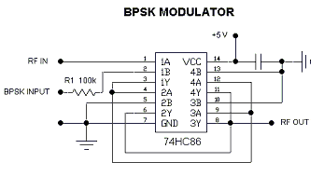
Figure 8. Simple BPSK modulator circuit using the high speed 74HC86 XOR gates.

Disadvantage of DSSS CDMA: near-far effect (unlike FHSS) when system is operating in fast fading environment, and capture effect where the strongest transmitter (assuming the closest of equal power transmitters) will dominate the demodulator. The power is mainly concentrated in the center lobe of the spectrum as shown in figure 9.
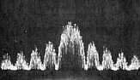

Figure 9. The power spectral density of the DSSS is concentrated at the main lobe of the spectrum.

A chipping code is assigned to represent logic 1 and 0 data bits. As the data stream is transmitted, the corresponding code is actually sent. For example, the transmission of a data bit equal to 1 would result in the sequence 00010011100 being sent.

When deciding which physical layer to use, consider the following characteristics of DSSS:

- Highest cost
- Highest power consumption
- Highest potential data rates from individual physical layers as compared to frequency hopping. (The current version of 802.11 specifies the same data rates for both frequency hopping and direct sequence; however, future versions of the standard are likely to support higher data rates for direct sequence.)
- Lowest aggregate capacity using multiple physical layers than frequency hopping.
- Smallest number of geographically separate radio cells due to a limited number of channels.
- More range than frequency hopping and infrared physical layers

In most cases, frequency hopping is the most cost-effective type of wireless systems to deploy if needs for system bandwidth is 2 Mbps or less. Direct sequence, having higher potential data rates, would be best for bandwidth intensive applications.

5. Capacity Analysis

The Frequency Hopping system is used to transmit data to other nearby receivers. One or more transmitter will transmit to one or more receiver. Transmitters and receivers are co-located in one local area such as supermarket or football field.

FHSS is a common diversity technique that combats fading, multi-path, and interference. The number of users in a given geographical area is then mostly dependant on the technique and not on other parameters. Factors such as propagation characteristics, terrain, spatial power density, and diversity technique [WCPP] used may play a role in determining the channel capacity of the system, that is the number of channels that can be active simultaneously within a given geographical area. For the purpose of this performance analysis we will make the following assumptions:

- Additive noise is kept to minimum. Internal and external noises are negligible in effect compared to interference.
- All transmitters are synchronized with the intended receivers. The synchronization process is a technique that deserves a special treatment.
- Fading is kept to minimum, for sake of capacity analysis, as it is being combated by frequency diversity.
- Transceivers are ON all of the times, except during maintenance, thus erlang principle [WCPP] would have little or no effect on this analysis.
- Signal sets are maximally orthogonal by the use of proper coding technique. Orthogonality can be implemented by hardware means or by software means. There are many smart software algorithms that can be used to randomize the transmitted signal symbols (PN Codes for Frequency Hopping) and can be implemented by using many programming languages such as Assembly language, C++, or Visual Basic. Due to severe jamming or harsh propagation characteristics the hopped signal might vanish before it reaches the receiver. In such a circumstance, coding is needed to detect and correct the received signal. There is multitude of coding algorithms [MAC] such as Forward Error Correction [DACS] (FEC.) This method improves the receiver sensitivity and consequently the signal quality. Improved Signal to Interference Ratio (SIR) or Bit Error Rate ratio (BER) may result in an improved Channel Capacity. The Bit Error Rate enhancement is translated into a Coding Gain (CG), due to FEC, of about 6 dB or higher. An example of coding techniques are Block Coding, Convolutional Coding [WCPP], or the source coding Blahut Algorithm [SCT] to combat coding distortion of fixed-rate data compression system with unconstrained block length or delay. In general, proper coding (when needed) and orthogonalization improve system performance and capacity.
- Receivers have matched filters or correlate with high efficiency. A decent system hardware and software design is assumed to correlate and match between the transmitted and the received signal symbols.

Transmitters and receivers will communicate effectively once hopped data is properly correlated (matched in filter) during the hopping sequence. One symbol is represented by V. The number of spread spectrum transmitters [PCE] is assumed to be U, the universe of system field. Each transmitter will transmit a defined set of symbols A. If all transmitters are active then the number of symbols transmitted for a complete hopping cycle, assuming non-infinity PN Code period with a reasonable clock frequency (say 240 KHz), is A·U symbols.

The transmitter (or receiver) counter is assumed to be k, and the symbol counter is assumed to be i:
1 ≤ i ≤ A, and 1 ≤ k ≤ U

An important factor that determines the systems performance (in term of signal to interference ratio and outage probability) and systems capacity (the number of signals the system can handle simultaneously) is the signal set.
Each symbol is assigned an identity , that is symbol accounted for from device (or user) k and position i from the symbols set of that device. Both the transmitter and the receiver carry the same PN Code (PNC) which enable them to understand each others. The PNC is made known to friendly pairs only and is concealed in identity from all non friendly pairs. Pairs, Transmitter(s) and Receiver(s), are symbol by symbol synchronized while identical pairs of PNC bits list are retrieved in the same order. Symbols are received one after another by the receiver and concatenated to form the entire signal. Due to extremely adverse propagation path, the symbols might suffer fading and multi path. The average signal strength is the sum of the instantaneous symbol strengths over certain period of time divide by the number of the received symbols. The Root Mean Square Signal Strength (RMS) is the square root of the average of the squares sum. Correlation occurs when the friendly pairs establish clear communication with minimum error.

The maximum number of the users signals w is determined by the magnitude of the maximum correlation . The error rate of the system is determined by the Root Mean Square of the correlation . Therefore, the maximum number of users that can be accommodated by the system given a reasonable error rate can be found by a specified value of maximum correlation and rms correlation respectively. A dimensional victor d has w sets, each set has A alphabets.

For an orthogonal signal set, the following applies:
≠
·
= 0,
(1)

Where i prime represents different symbol order than i from the same user. The power contained in each symbol is assumed to be constant:

| | ² = 1.
(2)

The number of the PNC codes contained in the list depends on:

- The processing gain and chip rate.
- Type of hopping (slow or fast.)

In slow hopping the hopping dwell time is longer than the symbol period (many symbols per hop), while in fast hopping the symbol period is longer than the hopping dwell time (many hops per symbol.)

The following defines the maximum correlation between symbols:

≡ max | . |, k ≠ k’.
(3)

The symbols are orthogonal when the maximum correlation is equal or less than 1. Assuming multiple transmitters, may or may not correlate (friendly or non friendly.) The input at the receiver under study due to multiple transmitters transmitting symbol i is:

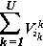
V = (synchronous operation)
(4)

Assume a bi orthogonal set of symbols carrying 2A alphabets (that is the orthogonal and their negatives) where:
(5)
≡ −
as it is illustrated below:

+1 ( Set1 ) +A
-A ( Set 1) -1
+1 ( Set 2) +A
Orthogonal set (A symbols)

Bi Orthogonal set (2A symbols)

The output of the kth receiver for the transmitted symbol i is then:
{
±1 +
1 ≤ i ≤ A
• V =

(6)

Where the impulse response of the filter corresponding to the bi orthogonal set is +1 for and –1 for . Symbol i that don’t correlate at receiver k is and outputted as an interference from U-1 transmitters:
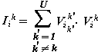
(7)
, 1 ≤ i ≤ A.

Minimum interference at the receiver, from non-friendly transmitters, occurs when correlation between symbols is minimum and the symbol set is very large in size. The receiver makes a decision based on the resulted magnitude of the correlation process inside it. If the receiver outputs a non zero magnitude for the correlated symbol i and another non zero magnitude of different value for the correlated i+1 symbol an error is detected. A software algorithm may be used to perform this detection and decision process:
| ± 1 | ≤ | |, and symbol belongs to the set.
≠

The overall mean square interference is the sum of the mean square interference from U-1 non-friendly transmitters. The following derivations will prove this right.

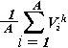
For k transmitters each sending A symbols, the probability of receiving the symbol from the orthogonal set A is 1/A under normal operating conditions. It is cumbersome to find the complete distribution probability of error, resulting at the receivers output du to kth transmitter, for each set due to the extremely random nature of this process combined with the synchronization establishment of non paired devices and correlation convolution. To make the process simple, let the mean output of the kth transmitter be { },
{
{ }
=
0,
Orthogonal

Bi orthogonal

(8)

For U transmitters in the system, the average interference is given by:

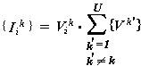
(9)

The difference between the interference and the average interference ∆ is - and the mean of the square {∆²} is:
{ }

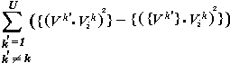
{∆²} =
(10)

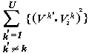
For bi-orthogonal set, the mean interference is 0 and the mean square {∆²} is given by:
{ }
{∆²} =
(11)

Which is consistent with the statement stated above for bi-orthogonal set, that is the mean square interference is the sum of the mean square interference due to U-1 transmitters. For the orthogonal set, the symbols mean level is:

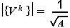
(12)

It is true that the equation derived for the bi orthogonal set may apply on orthogonal sets as well assuming that interference from different i symbols of kth device are approximately equal for simplified arithmetic. This assumption becomes very true and specially when all devices (transmitters and receivers) operate on Frequency Hopping and there is no phase coherence between hopping of pairs so interference diminishes to zero. In such a case, and where bi orthogonal sets containing 2 to the power A symbols are being utilized, the mean square interference would be approximately equal to that of orthogonal sets.

This is a strong motivation to use the MA frequency hopping Spread Spectrum technique with maximum possible code length to communicate information in a noisy environment. Thus, for number of users U >> 1 the interference appears to be approximately Gaussian with independent interference distribution. When the mean is zero then we may account for the average values for interference as it was shown above. We can modify the above mean-square interference equation to obtain a relation ship that describes the maximum number of system users in terms of a given correlation and signal set A.

For M users, the rms interference related correlation due to single user is:
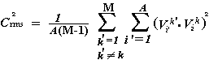
(13)

It is safe to assume that the error due to interference is equal or greater than the Gaussian interference due to all users in the system. The correlation interference due to M-1 users then could satisfy the following equality:
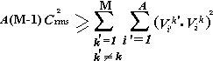
Assume non orthogonal for capacity calculation.
(14)

Welch manipulated the above equation (14) for obtaining the capacity of non orthogonal system in a d victor space containing M sets. The second summing term has a limit M:
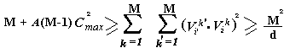
(15)

Solving (15) for M users in victor d in term of Cmax we get:
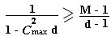
(16)

This relation (16) is illustrated in Figure 10 below:
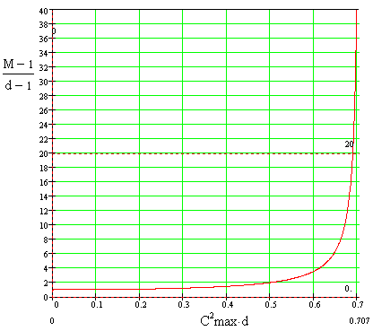

Figure 10. Correlation C versus number of users in a non orthogonal system.

From Figure 10 we observe that for a given victor dimension d (2 in this case), the non-orthogonal signal set frequency hopping spread spectrum interference correlation increases as the number of users M is increased. The parameter C²max. d [LBMC] reaches the asymptotes line of 1/sqrt(2) = 0.707, or the square the correlation C²max reaches the upper limit of 0.707 / d. For higher values of the dimension victor d, the interference maximum correlation drops in magnitude and forces a decrease in the number of system users. By the same analogy, for larger number of system users the interference maximum correlation increases in magnitude. To help combat this disadvantage of interference correlation we must take advantage of the orthogonal signal set system. Further more, the utilization of the bi-orthogonal signal set system gives the advantage of doubling the number of the users while maintaining the same quality of link.

The radio waves propagation losses are function of the operating frequency. Looses decrease as frequency increases. The radio signal losses are function of the material intercepting it as well [WCPP]. For example, an 815 MHz radio signal suffers 3.9 dB attenuation when intercepted by foil insulation. Antenna elevation also plays an important role in determining the propagation characteristics. The type of building and dividers used inside will also incur certain path loss on the radio signals. Researchers presented this phenomenon by the following log-distance path loss model equation:
(17)
PL (dB) = PL (Do) + 10n log (D/Do) + Xs

Where Xs is a building dependant standard deviation factor and n depends on the building and surrounding type. For example, considering same floor measurements, the standard deviation Xs is measure to be 12.9 dB on the average for 501 locations and n is 2.76. If the loss at Do is known then the loss at distance d within the same floor can be found for a given wireless system.

It is not easy to formulate a universal equation similar to (17) that describes losses for different buildings. Propagation patterns are very much dependant on material, setup, and the combinational arrangement of objects in the building or office. For an indoor wireless system operating over the 900 MHz band in the same floor, the path loss is about 72 dB for 10 meters separation between two transceivers. The path loss for 1 meter of separation is measured to be 31.5 dB. Power control may be implemented to combat a possible near-far field effect problem.

6. Performance Analysis

The micro cell short range same floor indoor hopping system is proposed to serve a security system by transmitting and receiving a synchronizing 120 Hz pulses. The number of transceiver units is assumed to be less than 20 units in certain market building.
In such an environment we assume that all transceivers are fixed in position, and are almost equally spaced from each other to combat the near-far-field effect. Most of the interference error sources are attributed to 1) Units within the system it self, 2) Interfering units from neighboring system, and 3) Extreme indoor activity such as large moving reflective objects, carts, large fans, and so on. The first and second source of error can be minimized or eliminated by providing a decent orthogonal capability built in to the system. The third source of error is minimized either by relocating the device if possible or providing manual (or automatic) control over the threshold levels. We will also assume that all units can be mounted on the ceiling. The Frequency diversity will most likely combat possible fading and multi path problems. The internal and external noise is assumed to be Gaussian in nature and is negligible.

The graph obtained above (d = 2) was for non-orthogonal worst case scenario of interference due to correlation. The following graph illustrates the effect of the number of sets victor d on the channel capacity. For the same number of users M, increasing the victor d will cause the interference to occur at lower levels of correlation.

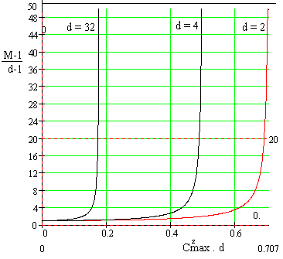

Figure 11. Correlation C versus number of users in a non orthogonal system and different dimensions victor d values.

A special zero correlation case occurs when the number of users and the size of the dimension victor d are equal. When there is only one user in the system then there will be no other device to correlate to and the interference is zero as can be seen from the graph above. When the dimension victor d is one there will be no bound on the number of users, an assumption that defeats the purpose of the system (for example all transceivers are operating in transmit mode only.)

Under normal operating conditions the dimension victor may take values greater than 1 only. The advantage of the bi-orthogonal may then be utilized to double the systems capacity for certain values of maximum correlation. The system designer engineer can facilitate the system with a feature that enables the systems administrator (upon demand of customer) to control the system capacity given certain number of users and threshold correlation levels. The software engineer would perform a criteria analysis, by an algorithm, to determine when to deny service of a requesting device in an effort to preserve a preset interference level. Since the system is proposed to provide service over short ranges the amalgamation of the hardware and the software will then provide an adjustable system channel capacity that tailors certain service area. The system administrator can then have a complete control over system channel capacity and service outage that depends on a variable threshold level. Quality of service depends on this threshold level and may be adjusted either manually or automatically depending on the selectable operating mode of the device. This control is not to exceed the limits set by the dimension victor d of the system, transceivers power specifications, and the sophistication of the system in term of orthogonal sets built into the system. A software algorithm may be designed, in conjunction with a test on situational operating conditions with time stamp, to analyze the user traffic and adjust the threshold level automatically upon the demand of the system administrator. Since the system is relatively small and the possibility of exposure to an adverse wireless channeling conditions is minimal, the need of coding scheme for error detection and correction is minimal. If processing speed is an issue then the administrator may widely adjust the dynamic number of system symbols and repeatedly cross the border between slow and fast hopping, on the expense of incurring possible interference. It is assumed that the signals remain orthogonal at all times. In case of frequency error due to leakage from the local oscillator or due to doppler shift [WCPP] then we may utilize an appropriate mapping of symbols to bit, such as the Grey Code [DCT], because the symbol error is very likely to occur in an adjacent frequencies. Thus the Grey Code mapping is appropriate to code the FSK modulation for error detection.

Recalling the correlation interference equation due to M-1 users:
(18)

Assume the worst case equal power transceivers TR interference at the center as shown in Figure 12, and a square spacing of 50 meters with equal symbol power as proposed in the figure below:

50 m
70.7 m
TR
TR
TR

Figure 12. Transceiver interference (worst case.)

The center TR receives interference from 8 adjacent TRs:
(19)
PL (dB) = PL (Do) + 10n log (D/Do) + Xs

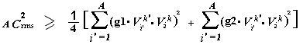 Then for 50 meters separation the loss L50 is 91.3 dB and for 70.7 meters separation the loss L70.7 is 95.4 dB. The signal V from transceiver k will attenuate by g1 = 2.7E-5 V/V for 50 meters and by g2 = 1.7E-5 V/V for 70.7 meters. Therefore the equation above (18) reduces to:
(20)

Assume that the corners TR power levels are higher than the 50 meters away TR by 4.1 dB in order to match with those at 50 meters distance, this will reduce to:
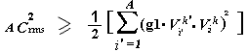
(21)

For one symbol transmitted, the non-orthogonal set correlation (21) reduces to:
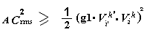
(22)

When the transmitter and the receiver maximally correlate for non-orthogonal set we got previously:
(23)

Solving for the above two equations (22) and (23) we obtain the following formula relating between separation factor g1, symbols set A, and channel capacity:

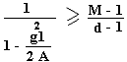
(24)

Where g1 is the separation factor. We can observe from last relation that for the same symbol set size, the system allows more users, on the expense of increasing correlation interference, if the separation factor is reduced or the symbol set is increased for a given geographical region. We can also deduce that for the same channel capacity, if the separation factor is increased then we may increase the symbol set in order to maintain the same grade of service GoS. A large number of users can be fitted into the system if the symbol set size is made much larger than twice the square of the separation factor.

Another important factor that determines the channel capacity and the outage probability [CMCC] is the Bit Error Rate (BER.) For a given processing gain (PG = SS band width / data rate), the outage probability can be expressed as:
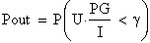
(25)

Where U is the attenuated received signal:
(26)

And I is the interference signal:
(27)

The designer must provide an acceptable margin of Signal to Noise Ratio (SNR.) That is the ratio of actual SNR to the threshold SNR. Signals and Noises are measured by their power levels and are expressed in dB.

There is a strong relation between bit error probability Pb(E), symbol error probability Ps(E), and bit energy to noise ratio Eb / No. The relation between bit energy to noise ratio Eb / No and symbol energy to noise ratio Es / No in an M-ary orthogonal set is as follow:
(28)

In non-coherent waveform communications in AWGN channels, and for a transmitted signal mk(t), detector output matched to the received signal Sk(t) is Ak, the probability that the received coded orthogonal signal correct is given by:
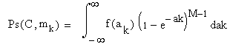
(29)

Where is a Rayleigh function of independent variables. The probability of the symbol error is given by 1 – Ps(C) or:
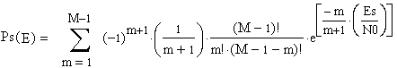
(30)

The probability that the un-coded symbol of non-coherent system is incorrect:

(31)
With:
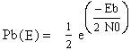
(32)

The probability of error for bi-orthogonal signal [DCT] is given by:
(33)

Where Ps2(E) is given by:
(34)

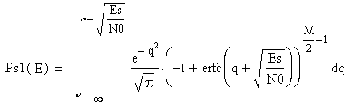 And Ps1(E) is given by:

(35)

Bi orthogonal coded signal, orthogonal coded signal, and un coded signal are all shown in Figure 13 for comparison purpose.

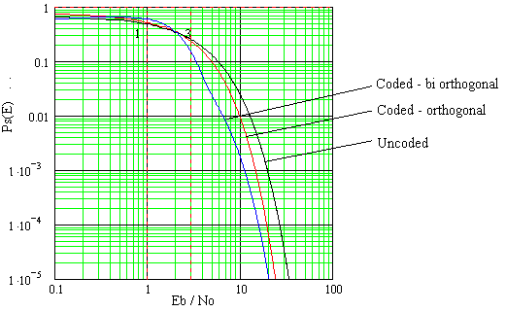

Figure 13. Probability of error versus Signal to Noise Ratio.

If we require a threshold SNR of 16 or 12 dB in a system operates on bi orthogonal coded detection, then for a processing gain of 1000 and a decent signal to noise ratio of 0.016 the probability of symbol error is about 0.0001. The Outage Probability (OP) increases as the SNR drops below 12 dB. As can be seen from the figure below, the bi orthogonal coherent detection is not much more effective than orthogonal non coherent detection as the signal to noise ratio gets higher. On the other hand, the ratio between coded and non coded detection for 0.001 probability of error is about 21 / 11 = 1.8 or about 2.6 dB. Therefore coding the transmitted signal is more effective in non coherent detection.

7. Application Example

A security System transmitter sends synchronizing pulses to friendly nearby systems receivers units. The environment is such that the receivers may not be able to recover the intended friendly signals due to multi path, fading, Near-Far-Effect, interference, jamming, and frequency shift. In reality, there are many other factors that may alters the intended friendly signal at the antenna of the receiver such as adverse channel characteristics, antennas used, and technology availability. The Spread Spectrum technology is an ideal candidate that can be chosen to combat the adverse effects suffered by the intended friendly signal.

Frequency hopping is an example of the Spread Spectrum technology used to provide an enhanced recovery of the non coherent signal by applying frequency diversity detection. This will provide an excellent Signal to Noise Ratio (SNR), efficient unlicensed use of Radio Spectrum, and great immunity to jamming and taping. There are many companies that provide an ample of support and information to implement this diversity technique. Among these companies are National, Maxim, Motorola, Philips, Microchip, Exar, Texas Instruments (TI), and Radio Frequency Micro Devices (RFMD.) Many circuits can be used to implement this wireless link. Some companies provide Chip Sets (CS) for the design of FHSS or DSSS, others provide single chips such as micro controllers and Frequency Shift Keying (FSK) encoder ship, Power and Low Noise Amplifiers, Filters such as Low Pass Filter (LPF), Voltage Controlled Oscillator (VCO), and Frequency Modulator. System can be designed from these parts in to tailor specific functions. The above mentioned companies provide an excellent on line Application Notes that will help design, build, and test an application specific system for consumer, commercial, and industrial use.

The Hardware design is beyond the scope of this paper but will only present a simplified block diagram to implement the FHSS Transmitter, Figure 14, and Receiver, Figure 15, (Transceiver) system:

FSK

Power Amplifier

LPF

Oscillator
Data in
0110101
Antenna
Sync

Figure 14. Simplified FHSS transmitter block diagram.

Low Noise Amplifier LNA
Antenna

Tone Decoder

LPF

Oscillator
0110101
Sync

LPF
Data out

Figure 15. Simplified FHSS receiver block diagram.

Typical components that can be used to implement the design are the Exar XR2206 Monolithic Function Generator, the Motorola MC1496 PLL modulator, the Philips NE567 Tone Decoder, the National LM1496 Balanced Modulator – Demodulator, and the Microchip PIC16F84 [PICM] micro controller.

8. Conclusion

The FHSS was the frequency diversity choice to link data between transceivers in an adverse environment. The interference correlation was minimized when larger symbol set was used. System Capacity was also improved when the SNR and BER were improved and a larger PN Code was utilized, since Symbol Set size influence interference. Power control can be used to combat the near-far-effect and separation issues. The bi orthogonal coded detection method for non-coherent detection improved the quality of link (SNR) by about 2.6 dB.

References

CMCC. Deepak Ayyagari. “Cellular Multi Code CDMA capacity for integrated voice and data service”. IEEE communications J. vol. 17, NO 5, May1999, pp928-938.

WCPP. Theodore S. Rappaport. “Wireless Communications Principles and Practices”. Prentice Hall Communications Engineering and Emerging Technologies Series, Jul 1999, Pp1-22, 44-45, 123-133, 140-143, 325-336, 352-356.

THB. Kornel Terplan and Patricia Morrelae. “The Telecommunications Handbook”. CRC Handbook – IEEE. 1999. Pp1-49 1-129.

DACS. Leon W. Couch II. “Digital and Analog Communication Systems”. Fifth edition. Printice Hall. 1997. Pp19-30, 295-368, 66-68, 473-476,352-353, 357-366.

SSC1. Charles E. Cook, Fred W. Ellersick, Laurence B. Milstein, and Donald L. Schilling. “Spread Spectrum Communications”. IEEE Press, Communications Society, 1983, Pp57-67.

DCT. Marvin K. Simon, Sami M. Hinedi, and William C. Lindsey. “Digital Communications Techniques – Signal Design and Detection”. PTR Prentice Hall, 1994, Pp42-43, 338-343, 211-212, 202-206, 216-217, and 321-333.

SSS. R. C. Dixon. “Spread Spectrum Systems”, New York, Wiley, 1976.

CWCP. William Webb. “The Complete Wireless Communications Professional – A Guide for Engineers and Managers”. Mobile Communications Series, Artech House Publishers – Boston / London, Pp8-9, 279-294.

MCSS. R. Cooper and C. D. McGillen. “Modern Communications and Spread Spectrum”. New York, NY, McGraw-Hill, 1986.

EDA. Richard J. Higgins. “Electronics with Digital and Analog Integrated Circuits”. Prentice-Hall, 1983, pp170-174.

AECS. Wayne Tomasi. “Advanced Electronic Communications Systems”. Prentice-Hall, New Jersey, 1987, Pp4-17.

SCT. Robert M. Gray. “Source Coding Theory”. Kluwer Academic Publishers, Boston – Dordrecht – London, 1990, Pp96-97.

MAC. Norman Abramson. “Multiple Access Communications – Foundations for Emerging Technologies”. IEEE Press, Information Theory Society, New Jersey, 1992, Pp221-222.

PCE. Wozencraft and I. M. Jacobs, “Principles of Communication Engineering”. New York, Wiley, 1965, Chapter4.

LBMC. L. R. Welch, “Lower Bounds on the Maximum Cross Correlation of Signals”. IEEE, Information Theory, Volume IT-20, May 1974, pp397-399.

PICM. John Iovine, “PIC Microcontroller Project Book”. McGraw-Hill, 2000, pp35-91.

